**Digital Thermometer**

**INTRODUCTION**

Thermometers are the device we use to measure the temperature in any desired scale and we all will be quite familiar with the analog thermometers. There are some disadvantages in analog thermometers and this can be overcome by using this digital thermometer using avr. The above embedded system shows the design and simulation of a simple Digital Thermometer using Atmega32 (AVR),  LM35 & 16×2 LCD.

**COMPONENT REQUIRED**

Hardware: ATMEGA32 Microcontroller, power supply (5v), AVR-ISP PROGRAMMER, JHD_162ALCD (16x2LCD), 100uF capacitor (two pieces), 100nF capacitor, LM35 Temperature Sensor.

Software: Atmel studio 6.1, SimulIDE.

**LM35**

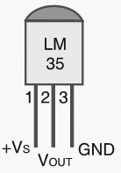

LM35 is a Precision temperature sensor IC with its output proportional to the temperature (in degree Celsius). LM35 is capable of giving accurate temperature readings compared to thermistor. The senor is sealed to avoid the effects of oxidation and other factors.

**16 X 2 LCD**

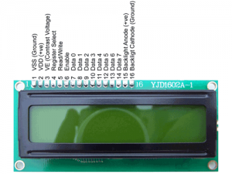

LCD (Liquid Crystal Display) is widely used electronic display module and got a wide range of applications. A 16×2 LCD consists of 16 columns and 2 rows thereby it is capable of displaying 16 characters in a single line. It consists of two registers, Command register used to store the command instructions given to the LCD. Whereas Data Register used to store the data’s to be displayed in the LCD.

**WORKING**

LM35 is an analog sensor that converts the surrounding temperature to a proportional analog voltage. The output from the sensor is connected to one of the ADC channel inputs of the Atmega32 microcontroller to derive the equivalent temperature valuein digital format.

**CIRCUIT DIAGRAM**

